Q1. Perform following steps

Use super user / sudo whenever needed

- Create /home/EXAM_DATA folder

- Folder should be accessible by every user of the system

- store students_details.csv in /home/EXAM_DATA folder

- Create a user asd

- Switch to newly created user asd

- Write shell script to search all lines having "PG-DBDA" and store it in "~/DBDA/dbda_records.csv" file

- Write shell script to search all lines having "PG-DAC" and store it in "~/DAC/dac_records.csv" file

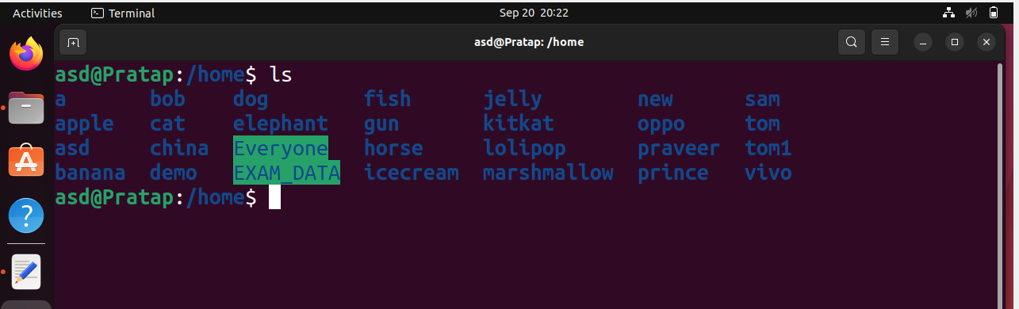

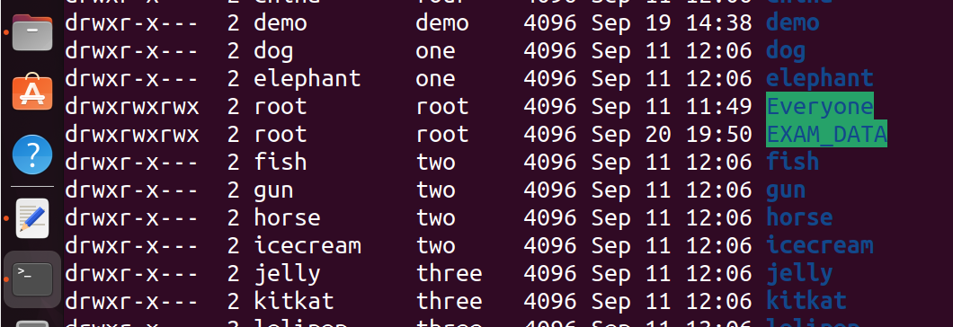

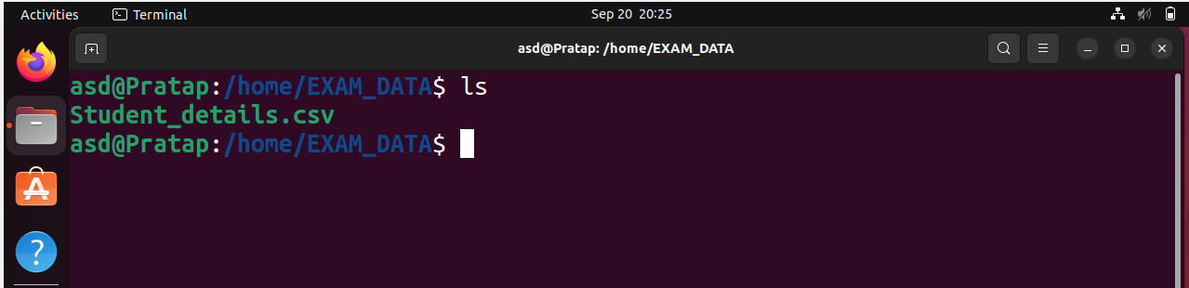



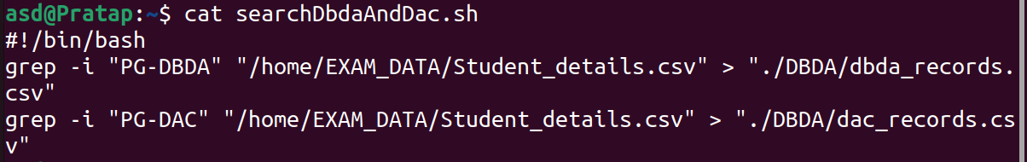

Q2. Perform following steps

- login as asd user

- Crate two files my.csv and friend.csv in home directory

- In my.csv write 1 line about yourself and save it

- In friend.csv write 1 line about friend and save it

- Write the shell script that puts contains of all csv files in current folder into a file all.csv

Ex. contents of my.csv and friend.csv should be present in all.csv file



